1. Seller and Inventory Table Design
Seller Table
The Seller table stores information about the sellers who provide the products.
Column Name | Data Type | Key | Description
seller_id | INT | Primary Key | Unique ID of the seller
seller_name | VARCHAR(100) | — | Name of the seller
email | VARCHAR(100) | — | Email address of the seller
phone | VARCHAR(15) | — | Phone number of the seller
Inventory Table
The Inventory table stores information about the products and their available quantities.
Column Name | Data Type | Key | Description
inventory_id | INT | Primary Key | Unique ID of the inventory item
product_name | VARCHAR(100) | — | Name of the product
quantity | INT | — | Number of products available
price | DECIMAL(10,2) | — | Price of the product
seller_id | INT | Foreign Key | ID of the seller
Relationship
The seller_id in the Inventory table is a foreign key that refers to the seller_id in the Seller table.
Relationship:
One Seller → Many Inventory Products
A seller can have many products in the inventory, but each inventory product belongs to one seller.

2. ER Relationship Diagram Update

+----------------------+
| SELLER |
+----------------------+
| Seller_ID (PK) |
| Seller_Name |
| Email |
| Phone |
+----------------------+
|
| 1
|
| MANY
+----------------------+
| INVENTORY |
+----------------------+
| Inventory_ID (PK) |
| Product_ID (FK) |
| Seller_ID (FK) |
| Stock_Quantity |
| Reorder_Level |
| Last_Updated |
+----------------------+
|
| MANY
|
| 1
+----------------------+
| PRODUCT |
+----------------------+
| Product_ID (PK) |
| Product_Name |
| Price |

Relationship Description
- One seller can have many inventory records.
- Each inventory record belongs to one seller.
- One product can appear in many inventory records.
- Each inventory record belongs to one product.

3. SQL Table Creation Script
The SQL table creation script is used to create the Seller and Inventory tables in the database.
Database Creation
CREATE DATABASE weeek3_db;

USE weeek3_db;
Seller Table
CREATE TABLE seller (
seller_id INT PRIMARY KEY AUTO_INCREMENT,
seller_name VARCHAR(100) NOT NULL,
email VARCHAR(100),
phone VARCHAR(15)
);
Explanation:
The seller table stores the details of sellers such as seller ID, name, email, and phone number.
Inventory Table
CREATE TABLE inventory (
inventory_id INT PRIMARY KEY AUTO_INCREMENT,
product_name VARCHAR(100) NOT NULL,
quantity INT NOT NULL,
price DECIMAL(10,2),
seller_id INT,
FOREIGN KEY (seller_id) REFERENCES seller(seller_id)
);
Explanation:
The inventory table stores product details such as product name, quantity, price, and seller ID.
The seller_id is a foreign key that connects the Inventory table with the Seller table.
Simple Summary
- seller → stores seller information.
- inventory → stores product and stock information.
- seller_id → connects both tables.
- PRIMARY KEY → uniquely identifies each record.
- FOREIGN KEY → creates a relationship between the tables.

4. Sample Seller and Inventory Records
4.1 Insert Seller Records
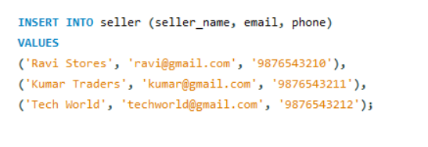
4.2 Insert Inventory Records
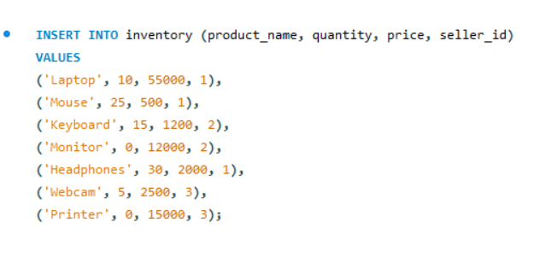

Sample Seller Data
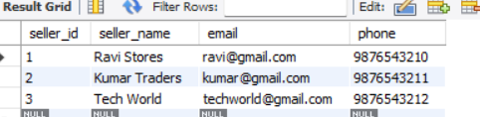
Sample Inventory Data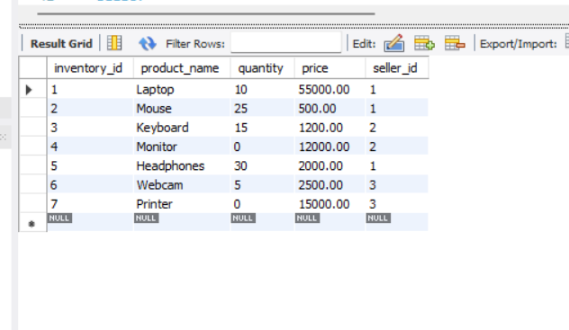

5. CRUD Operations
CRUD stands for:
- C – Create
- R – Read
- U – Update
- D – Delete

5.1 CREATE – Adding New Data
- CREATE means adding new records to the database.
- In our project, we use the INSERT INTO command to add data.
- Example: Add a new inventory product
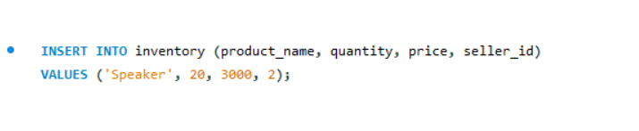
Simple Explanation
This query adds a new product called Speaker to the inventory.
- Product Name → Speaker
- Quantity → 20
- Price → ₹3000
- Seller ID → 2
So, Kumar Traders supplies the Speaker.
5.2 READ – Viewing Data
READ means retrieving or viewing the data stored in the database.
We use the SELECT command to read data.
Example : Display all sellers
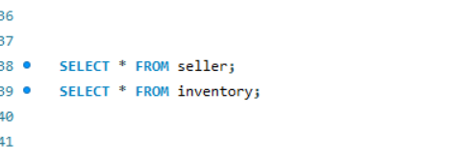

Simple Explanation
This displays all the records from the seller table.
It shows:
- Seller ID
- Seller Name
- Email
- Phone

5.3 UPDATE – Changing Existing Data
UPDATE means changing an existing record in the database.
We use the UPDATE command.

Example: Update product quantity

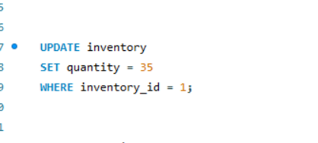

Simple Explanation
This query changes the quantity of the product with Inventory ID 1 to 35.
Before:
Laptop → Quantity = 10
After:
Laptop → Quantity = 35
The WHERE condition makes sure that only Inventory ID 1 is updated.

5.4 DELETE – Removing Data
DELETE means removing an existing record from the database.
We use the DELETE command.
Example: Delete an inventory record

Simple Explanation
This query removes the inventory record whose Inventory ID is 8.
The WHERE condition identifies which record should be deleted.
In the given data, the original inventory records have IDs 1 to 7. The Speaker record inserted later becomes ID 8, so this query deletes the Speaker record.

6. Inventory Analysis Queries
Inventory analysis queries are used to check and understand the stock available in the inventory.
6.1 Count Available Products
SELECT COUNT(*) AS total_products_available
FROM inventory
WHERE quantity > 0;
Explanation: Counts the products that have stock available.

6.2 Find Out-of-Stock Products
SELECT *
FROM inventory
WHERE quantity = 0;
Explanation: Displays products whose quantity is 0, meaning they are out of stock.

6.3 Find Product With Maximum Quantity
SELECT product_name, quantity
FROM inventory
WHERE quantity = (SELECT MAX(quantity) FROM inventory);
Explanation: Finds the product that has the highest quantity in the inventory.

6.4 Find Average Inventory Quantity
SELECT AVG(quantity) AS average_inventory_quantity
FROM inventory;
Explanation: Calculates the average quantity of products in the inventory.

6.5 Seller-wise Inventory Analysis
SELECT
s.seller_name,
COUNT(i.inventory_id) AS total_products,
SUM(i.quantity) AS total_quantity
FROM seller s
LEFT JOIN inventory i
ON s.seller_id = i.seller_id
GROUP BY s.seller_id, s.seller_name;
Explanation: Shows each seller's total number of products and total quantity of products.

Summary
These queries help us to:
- Find available products.
- Find out-of-stock products.
- Find the product with the highest quantity.
- Calculate average inventory quantity.
- Analyze inventory seller-wise.

